#### ABSTRACT

The goal of this project is to create a time table generator for colleges. The creation of schedules is a very common issue that affects all educational institutions. The conflict between staff members preferences is precisely where the issue arises. Every semester, colleges are required to create time tables, which used to be an extremely time-consuming task. Once the timetables are set for a given semester, the student is allowed to access them. Once the timetables are established for a particular semester, employees are also permitted to check the class allotment schedule.

The Time Table assignment for any department by information was added by the administrator for the staff, the subject, enter the timetable, and update the timetable. The majority of colleges offer a variety of programs, each of which has a number of disciplines. There are now a limited number of faculties, each of which teaches many disciplines. Therefore, the timetable now has to include the instructors at the appropriate times. the timetable schedule, which makes the most use of all faculty subject demands, slots so that their timings do not cross. We suggest using a timetable object in our method for creating timetables. This object consists of classroom objects, their respective schedules, and a fitness rating for the schedule.

**TABLE OF CONTENTS**

|  |  |  |
| --- | --- | --- |
| **S.NO** | **PARTICULARS** | **PAGE.NO** |
| 1 | **INTRODUCTION** |  |
| 1.1 Overview of the project |  |
| 2 | **SYSTEM STUDY** |  |
| 2.1 Existing System |  |
| 2.2 Problem Identification |  |
| 2.3 Proposed System |  |
| 3 | **SYSTEM CONFIGURATION** |  |
| 3.1 Hardware Requirements |  |
| 3.2 Software Requirements |  |
| 3.3 Software Description |  |
| 4 | **SYSTEM DESIGN** |  |
| 4.1 Module Description |  |
| 4.2 Form Design |  |
| 4.3 Database Design |  |
| 4.4 Design Notations |  |
| 5. | **SYSTEM TESTING AND IMPLEMENTATION** |  |
| 5.1 System Testing |
| 5.2 System Implementation |
| 6 | **CONCLUSION AND FUTURE ENHANCEMENT** |  |
| 6.1 Conclusion |  |
| 6.2 Future Enhancement |  |
|  | **BIBLOGRAPHY** |  |
|  | **APPENDIX** |  |
| A. Screen Shots |  |
| B. Source Code |  |

#### 1.INTRODUCTION

* 1. **OVERVIEW OF THE PROJECT**

An automated timetable generator is a software system designed to efficiently create schedules for various activities, such as classes, meetings, events, or resource allocations, based on input data and predefined constraints. Details about the activities to be scheduled, including their duration, frequency, and any dependencies or relationships between them. The input data is processed and organized to ensure consistency and compatibility with the scheduling algorithm. Data validation and error checking are performed to identify any inconsistencies or conflicts in the input data. Once the timetable is generated and validated, it is presented to the users in a user-friendly format. The automated timetable generator should have an option for users to download the timetable as a PDF document. The system should provide users with the ability to share the timetable via email directly from the application interface. Users should have the option to print the timetable directly from the application interface.

Ensure that the generated PDF timetable is formatted appropriately for printing, with clear fonts, proper spacing, and legible text. Implement security measures to protect sensitive information in the timetable PDF, such as student or faculty personal data. Provide options for users to customize the appearance of the printed timetable, such as selecting color schemes or including additional details. Test the PDF generation, email sharing, and printing functionalities across different devices and web browsers to ensure compatibility and reliability. Consider implementing access controls or permissions to restrict who can download, share, or print the timetable, based on user roles or institutional policies. By providing these functionalities, the automated timetable generator offers users convenient ways to access, share, and distribute the generated timetable, enhancing usability and accessibility for all stakeholders involved.

**2. SYSTEM STUDY**

**2.1 EXISTING SYSTEM**

Normally timetable generation done manually. As we now all Institutions or organizations have its own Timetable, managing and maintaining these will not be difficult. Considering workload with this scheduling will make it more complex. As mentioned, when Timetable generation is being done, it should consider the maximum and minimum workload that is in a college. In those cases, Timetable generation will become more complex. Traditionally, timetables are created manually by administrators or schedulers. This process is time-consuming, prone to errors, and often inefficient, especially in large organizations or institutions with complex scheduling requirements. Some institutions use spreadsheets or basic scheduling software to create timetables. While these tools offer some automation and organization, they may lack advanced features and flexibility needed to handle complex scheduling constraints. Manual or basic software-based timetabling often lacks sophisticated optimization algorithms. As a result, the generated timetables may not be optimal in terms of resource utilization, room allocation, or minimizing conflicts.

**2.2 PROBLEM IDENTIFICATION**

Automatic Timetable Generator is a used to generate timetable automatically. Currently timetable is managed manually. Avoid the complexity of setting and managing Timetable manually. It will help you to manage all the periods automatically. It will help to manage all the periods automatically and also will be helpful for faculty to get timetable for their classes. It is a timetable management solution for colleges which help to overcome the challenges in manually setting the timetable. By using this it will be very easy for faculty to get timetable.

**2.3 PROPOSED SYSTEM**

Automatic Timetable generator is a php based software used to generate timetable automatically. Will help you to manage all the periods automatically. Proposed system will help to generate it automatically also helps to save time. There is no need for Faculty to worry about their period details and maximum workload. It is a comprehensive timetable management solution for colleges which helps to overcome the challenges in current system. All dependencies are satisfied from the opensource projects. All tools used are free, open source and the programming language is easy to work hence its development is economically. In this there is availability for extracting the reported timetable by downloading as pdf, share through mail, print as per requirement. Also table with time scheduling and clear view of timetable is available.

**3.SYSTEM CONFIGURATION**

**3.1 HARDWARE REQUIREMENTS**

* Processor : Intel i5-1135G7 above (2.40 GHz speed)
* Hard Disk : 40 GB(Needed)
* Mouse : Optical, wired
* RAM :8GB

**3.2 SOFTWARE REQUIREMENTS**

* Operating System : Windows 11 (23H2)
* Front End : PHP (8.3)
* Browser : Google chrome (122.0.6261.112)
* Database : MYSQL (version-5.5)
* Web Server : XAMPP (v3.3.0)
* Designing : HTML(HTML5), CSS(CSS3)
* Validation : JavaScript (ES6)

#### SOFTWARE DESCRIPTION

#### PROGRAMMING LANGUAGES

#### HTML

Hypertext Markup Language (HTML) is the standard mark-up language for creating web pages and web applications. Web browsers receive HTML documents from a webserver or from local storage and render them into multimedia web pages. HTML describes the structure of a web page semantically and originally included cues for the appearance of the document. Web browsers receive HTML documents from a webserver or from local storage and render them into multimedia web pages. HTML describes the structure of a web page semantically and originally included cues for the appearance of the document.

#### CSS

Cascading Style Sheets (CSS) is a style sheet language used for describing the presentation of a document written in a mark-up language. Although most often used to set the visual style of web pages and user interfaces written in HTML and XHTML, the language can be applied to any XML document, including plain XML, SVG and XUL, and is applicable to rendering in speech, or on other media. Along with HTML and JavaScript, CSS is a cornerstone technology used by most websites to create visually engaging web pages, user interfaces for web applications, and user interfaces for many mobile applications. CSS is designed primarily to enable the separation of presentation and content, including aspects such as the layout, colors, and fonts. This separation can improve content accessibility, provide more flexibility and control in the specification of presentation characteristics, enable multiple HTML pages to share formatting by specifying the relevant CSS in a separate .CSS file, and reduce complexity and repetition in the structural content.

#### FRONT END-PHP

PHP is a language that has outgrown its name. It was originally conceived as a set of macros to help coders maintain personal home pages, and its name grew from its purpose. Since then, PHP's capabilities have been extended, taking it beyond a set of utilities to a full-featured programming language, capable of managing huge database-driven online environments.

PHP is now officially known as PHP: Hyper Text Preprocessor. It is a server-side scripting language usually written in an HTML context. Unlike an ordinary HTML page, a PHP script is not sent directly to a client by the server; instead, it is parsed by the PHP binary or module. HTML elements in the script are left alone, but PHP code is interpreted and executed. PHP code in a script can query databases, create images, read and write files, talks to remote servers - the possibilities are endless.

The output from PHP code is combined with the HTML in the script and the result sent to the user. The first version of PHP was created by Rasmus Lerdorf in 1994 as a set of Web publishing macros. These were released as the Personal Home Page Tools and later rewritten and extended to include a package called the Form Interpreter (PHP/FI). From a user's perspective, PHP/FI was already an attractive proposition, and its popularity grew steadily by 1997, a team of programmers was working on the project. The next release— PHP3— was born out of this collaborative effort. PHP3 was an effective rewrite of PHP, with an entirely new parser created by Zeev Suraski and Andi Gutmans, as well as differences in syntax and new features. This release established PHP as one of the most exciting server scripting languages available, and the growth in usage was enormous. PHP's support for Apache and MySQL further secured its popularity. Apache is now the most-used Web server in the world, and PHP3 can be compiled as an Apache module. MySQL is a powerful free SQL database, and PHP provides a comprehensive set of functions for working with it.

#### BACK END-MY SQL

Databases are a great way to store information they can store your personal contact list, your financial records, your household inventory, or even a listing of your favorite websites. Databases are able to store large amounts of useful information in a logical structure that allows for quick retrieval in any user defined format. Community libraries are renowned for their use of large database systems to store the mass amounts of usable information that they collect and share.

Databases also play a major role in today’s web applications by storing complete inventories of products and services and making these accessible through a programmed web front-end. A database has the ability to provide dynamic content to a web shop by providing the content to web pages. Many Linux distributions implement PHP, MySQL, and Apache as a perfect combination for full featured dynamic.

### 4.SYSTEM DESIGN

* 1. **MODULE DESCRIPTION**

In the timetable generator there are four module of pages is used to generate the timetable. In each of these the requirement of details is mandatory for the timetable generation. Each of the detail is mandatory and used for generating table. Based on the inputs the timetable is used to systemize the timetable. The main efficient and feature of each module is their interconnection and working. Only with the help of one module the other respective module is available then it will make it work and useful for this timetable generation. Before working into these, the staff have to login before accessing. The staff should be a member of the department and data of the staff should be registered in the staff table for login purpose.

**SEMESTER SCHEDULE**

In this module the details of semester and class name for which class the timetable is going to be generated and subjects what all are going to learned by them in that particular semester. In the semester there will be able to give in certain number range. All the subjects name were provided as input with comma separated in between each subject. In this also there is availability for checking with the subjects of semester in each semester. After the details it is able to proceed with the next module for creating the timetable generation.

**STAFF ASSIGNMENT**

In this module the details given in the module-I is available which is used to verify once of the data given is correct or not. If there need to change in the given data it is possible to change the given data by goback option. In this module-II it is used to collect staffs name for each subject given in the before module. Based on the need the names can be given as full name or alias name for each subject then it is able to move to the next module for further steps to generate the timetable.

**SCHEDULE CONFIRMATION**

In this module the details of the staff name and their teaching subjects will be displayed, it is used to refer once the subjects and staff names. Apart these in this gather the input of number of days, number periods per day will be collected. By getting these data, the timetable will be generated based on number of days and periods along with the number of subjects given in the first module.

**TIMETABLE GENERATION**

In this last module the timetable will be generated as a report. The generated timetable will be displayed in the table format with neat representation. There will be another table with time allocation for each period will be displayed in that table. The table will be in a well structure format also there is options available to extract the report of timetable in different ways like downloading the generated timetable as pdf, share the generated timetable through mail to the other, when there is need to takeout the printout it is easy to print the timetable generated using the print option. Like that of the generated will be extracted easily and it is easy to maintain and use the timetable and timetable generator.

**4.2 FORM DESIGN**

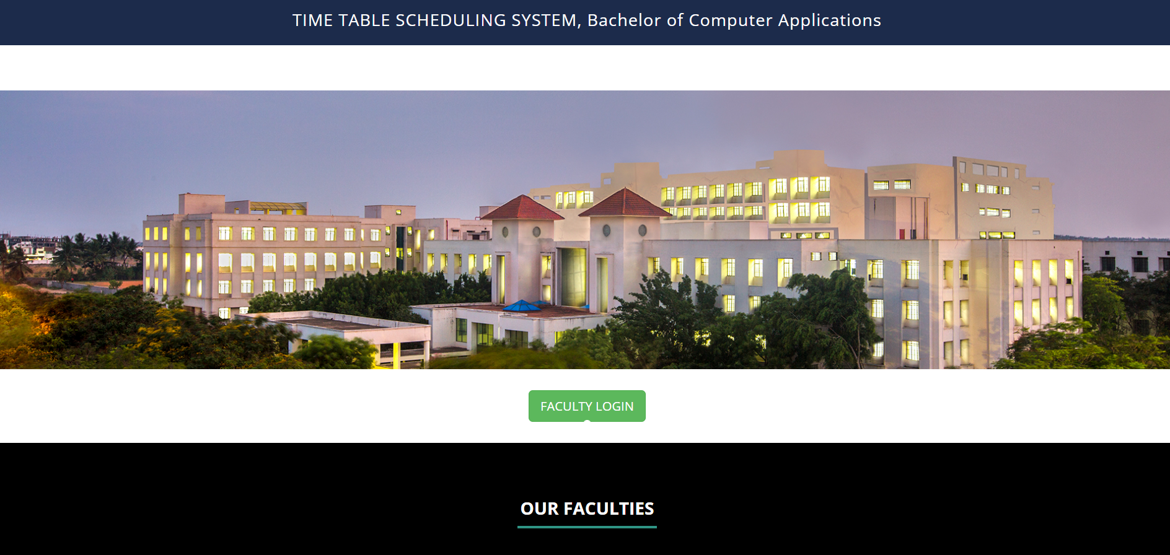

**HOME PAGE**

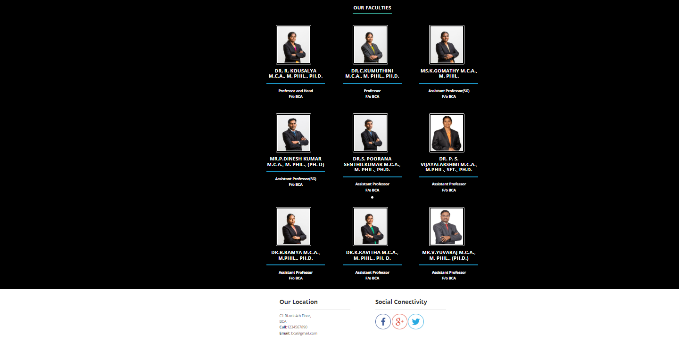

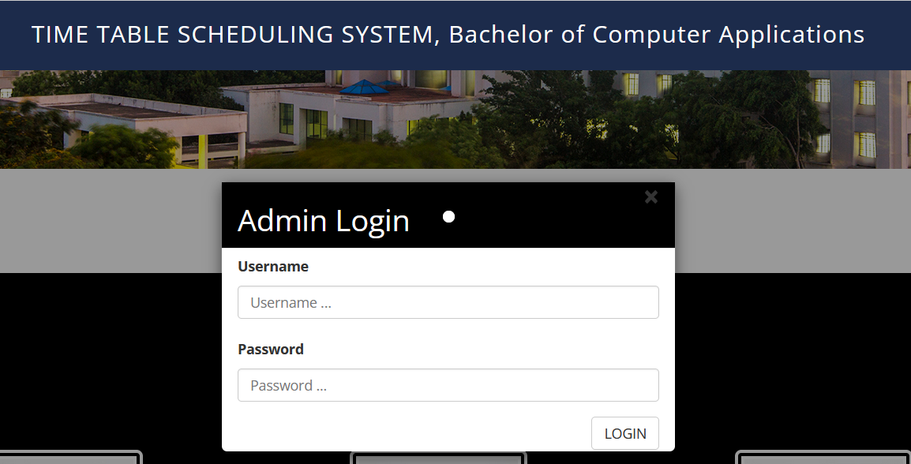

**LOGIN PAGE**

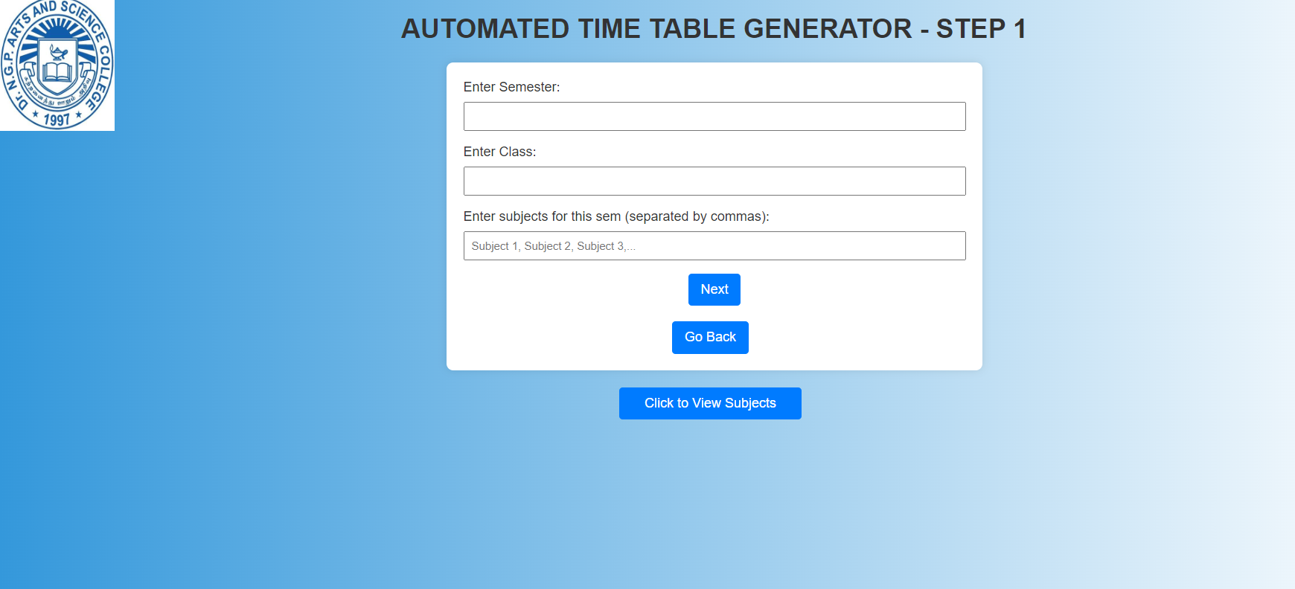

**SEMESTER SCHEDULE PAGE**

After giving data in the semester scheduling page, based on that the next pages will proceed to work and make the process based on the data available and requirement then it will work and produces a result of generating the timetable.

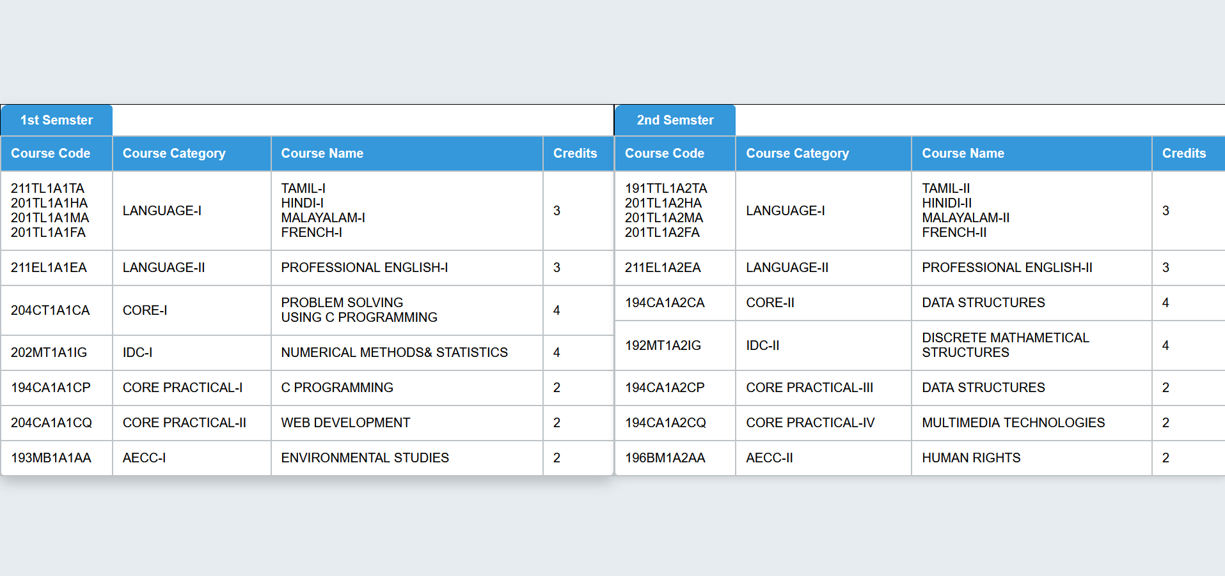

**SEMSETER SUBJECT PAGE**

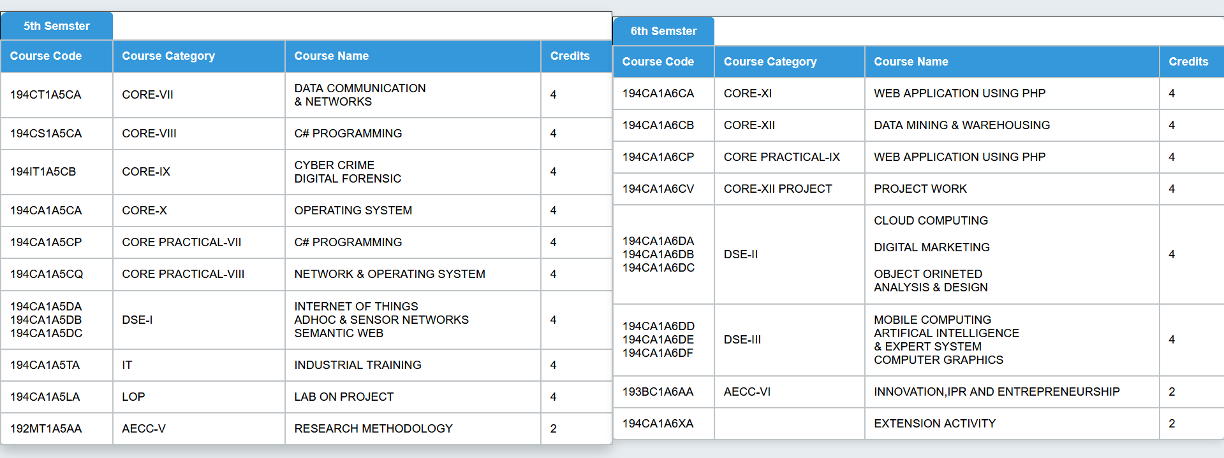

**SEMSTER SUBJECT PAGE**

**4.3 DATABASE DESIGN**

The data pertaining to proposed system is voluminous that a careful design of the database must Precede design of the database must proceed before storing the data in the database. A database management system provides flexibility in the storage and retrieval of data held production of information. The DBMS is a bridge between the application programs. This determines what data are needed and how they are processed and the operating system of the computer, which is responsible for placing data on the magnetic storage devices. A schema defines the database and a sub scheme defines the portion of the database that a specific program will use

**Table Name:** Staff Table

|  |  |  |  |  |
| --- | --- | --- | --- | --- |
| **Serial No:** | **Column Name** | **Column Description** | **Datatype** | **Constraints** |
| 1 | Staff Name | Individual Staff Name | Varchar (20) | Not Null |
| 2 | Staff ID | Staff Identification Number | Varchar (10) | Primary Key |

In this staff name and staff id used for their logging for scheduling the timetable, based on the data they give for login by that, they will move for the next process of scheduling.

**4.4 DESIGN NOTATION**

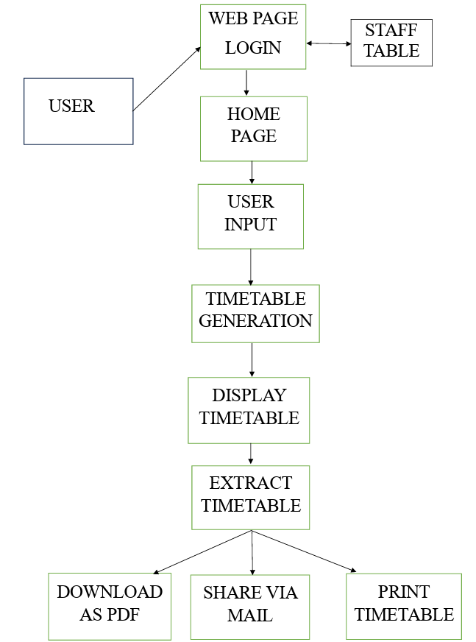

### 5.SYSTEM TESTING AND IMPLEMENTATION

#### SYSTEM TESTING

The system thus developed is tested for its efficiency. The testing method is one of the most essential criteria of developing the software. System testing is vital for the success of any software system. The system testing makes a logical assumption that all parts of the system works efficiently and the goals are achieved. System testing requires attest plan that consists of several key activities and steps for programming and user acceptance testing.

After each program passes its own test, it is linkage to the other programs is scrutinized with a program integration test. This ensures that the program work together as intended. Before the implementation phase the designed system should be tested with raw data to ensure that all modules of the system work correctly and satisfactorily. If some bug is found they can be removed before the implementation phase.

Which individual units of source code, sets of one or more computer program modules together with associated control data, usage procedures, and operating procedures are tested to determine whether they are fit for use. In my Project each and every module gets tested like input module of each form.

## 

#### 5.2 SYSTEM IMPLEMENTATION

Implementation is the stage of the project, when the theoretical design is turned into a working system. System is the major factor. Impact on existing practices shift to user department. If the implementation stage is not carefully, planned and controlled. Thus, it cannot be considered to be the more crucial stage in achieving a successful new confidence that the system will work more effectively.

The implementation stage is a system project in its own right. It involves careful planning, investigation of the current system and its constraints on implementation, design of methods to achieve the change our procedures, and evaluation of change over methods.

The implementation plan consists of the following sample steps.

* + - Testing the developed system with sample data.
    - Detection and correction of errors.
    - Making necessary changes in the system.
    - Checking the reports with that of the existing system.
    - Training and involvement of user personnel.
    - Installation of hardware and software utilities.
    - The implementation of the system is easy for any system environment as the software is portable one.

#### IMPLEMENTATION PROCEDURES

The implementation phase is less creative than system design. A system project may be dropped at any time prior to implementation, although it becomes more difficult when it goes the design phase. The final report to the implementation phase includes procedural flowcharts, report layouts, and a workable plan for implementing the candidate system. Implementation is used to the design into an operational one. Conversion is one aspect of implementation. The implementation view of software requirements presents the real-world manifestation of processing function and information structures. In some case, a physical representation is developed as the first step in software design. The analyst must recognize the constraints imposed by predefined system elements in and consider the implementation view of function and information when such view is appropriate.

#### Implementation Plan

System implementation is the process of making the newly designed system fully operational. The system is implemented after careful testing. Implementation is a stage in the project where theoretical design is turned into working system in order to maximize efficiency and productivity. The most critical stage in achieving a new system is in getting the approval from the system manager. The newly designed system put into work process, after the testing is over. The system will be implemented in phase along with existing system and it take over happens when the full testing is defined to be perfect, till then the parallel run is done.

Implementation procedures are

* + - Implementation simply means converting a new computer system to replace an existing one.
    - Implementation of computer system to replace a manual system.

After the data has been initially set, the system is ready for use. The change over from the existing system to new system is a step-by-step process.

## 6. COCLUSION & FUTURE ENHANCEMENT

#### 6.1 CONCLUSION

The developed project timetable generator helps to successfully generate a timetable. It provides a flexible interface for specifying the inputs and it also helps to customize and visualize schedules based on their preferences. This timetable generator project will be a good one for the users who all like to know about the sources used and like to make their work simple and efficient as they needed.

Thus, the project entitled “Timetable Generator” was successfully completed and implemented. The project was developed as per the life cycle of PHP Testing it was also carried out in a different format that specifically defines each transaction. Various end-users were also tested online to prove the efficiently of the project before the major implementation.

* 1. **FUTURE ENHANCEMENT**

The future work of the project is to scheduling the timetable for few more classes and also makes the allotment for the staffs without any clashes in the timetable. Also try to replace the staff if there were on leave or in another work, by using their availability and their work schedule.

#### BIBLOGRAPHY

#### BOOK REFERENCE

* Robin Nixon, (2018),” Learning PHP, MySQL & JavaScript: with jQuery, CSS & HTML5”-5th Edition, O’Reilly Publications.
* Joel Murach, Ray Harris, (2017),”PHP and MySQL”-3rd Edition, Murach Press.
* David Sklar, Adam Trachentberg, (2014),”PHP Cookbook: Solutions & Examples for PHP Programmers”-3rd Edition, O’Reilly Publications.
* Luke Welling, Laura Thomson, (2016),”PHP and MySQL. Web Development”-5th Edition, Developer’s Library.
* ‘Thomas A’, (2010), ‘The Complete Reference HTML &CSS’, Fifth Edition.

#### REFERENCE WEBSITES

* <https://www.w3schools.com/php/php_ref_overview.asp>
* <https://www.w3schools.com/php/php_forms.asp>
* <https://www.w3schools.com/php/php_form_validation.asp>
* <https://www.tutorialspoint.com/php/php_and_mysql.htm>

### APPENDIX

1. **SCREENSHOTS**

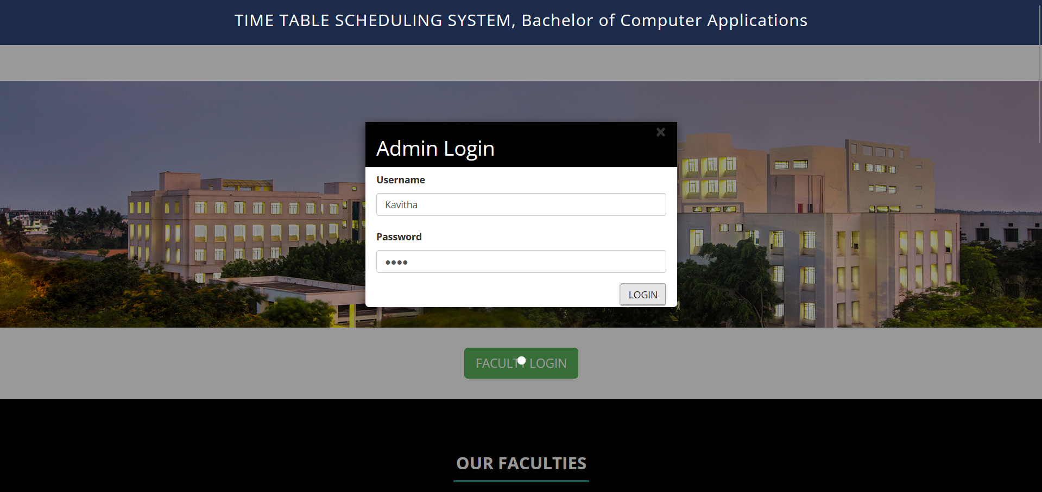

**LOGIN**

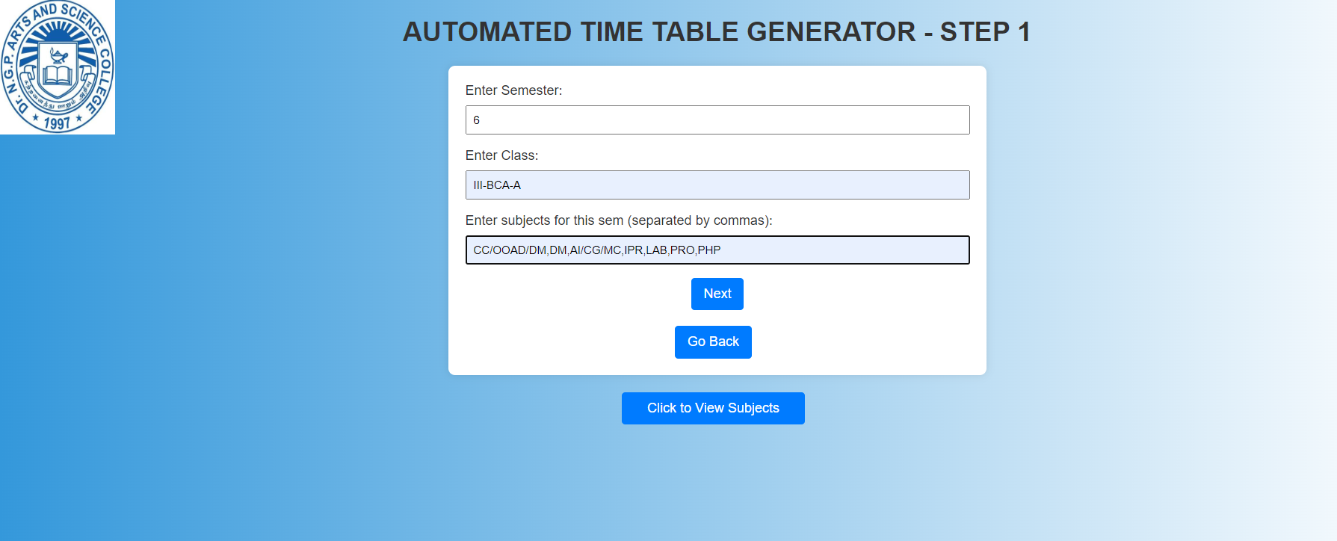

**SEMESTER SCHEDULE**

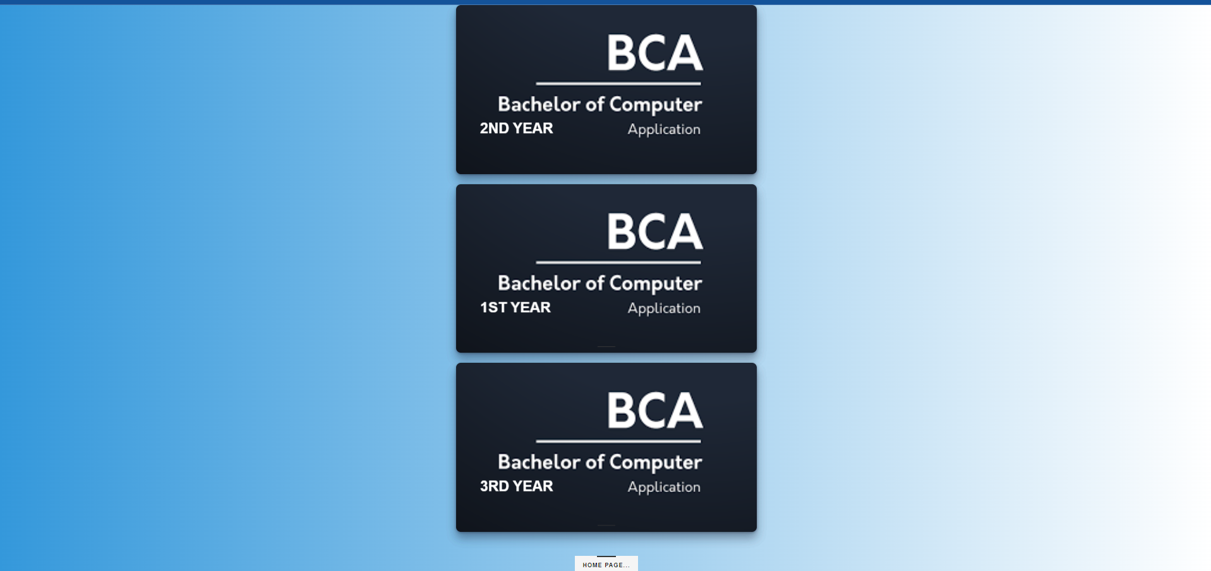

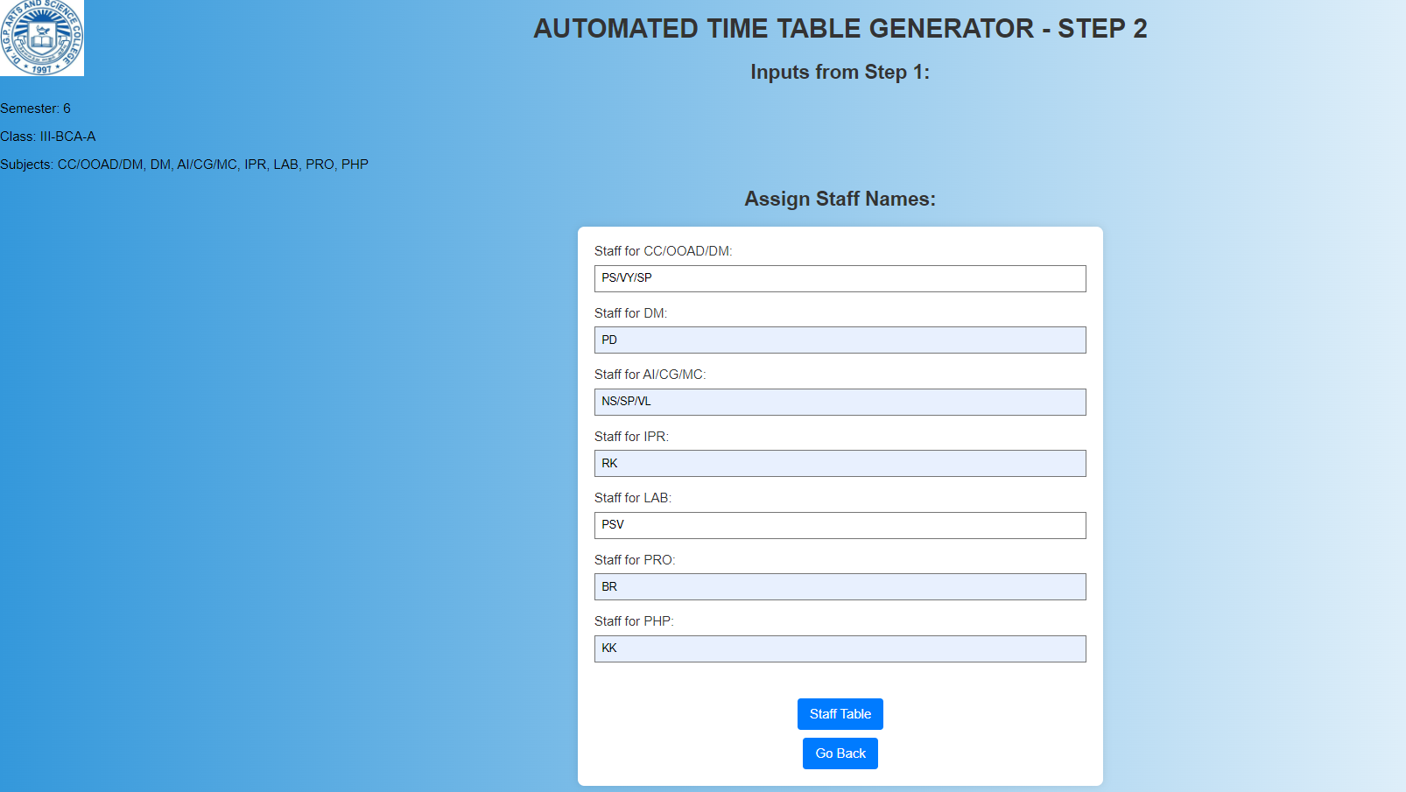

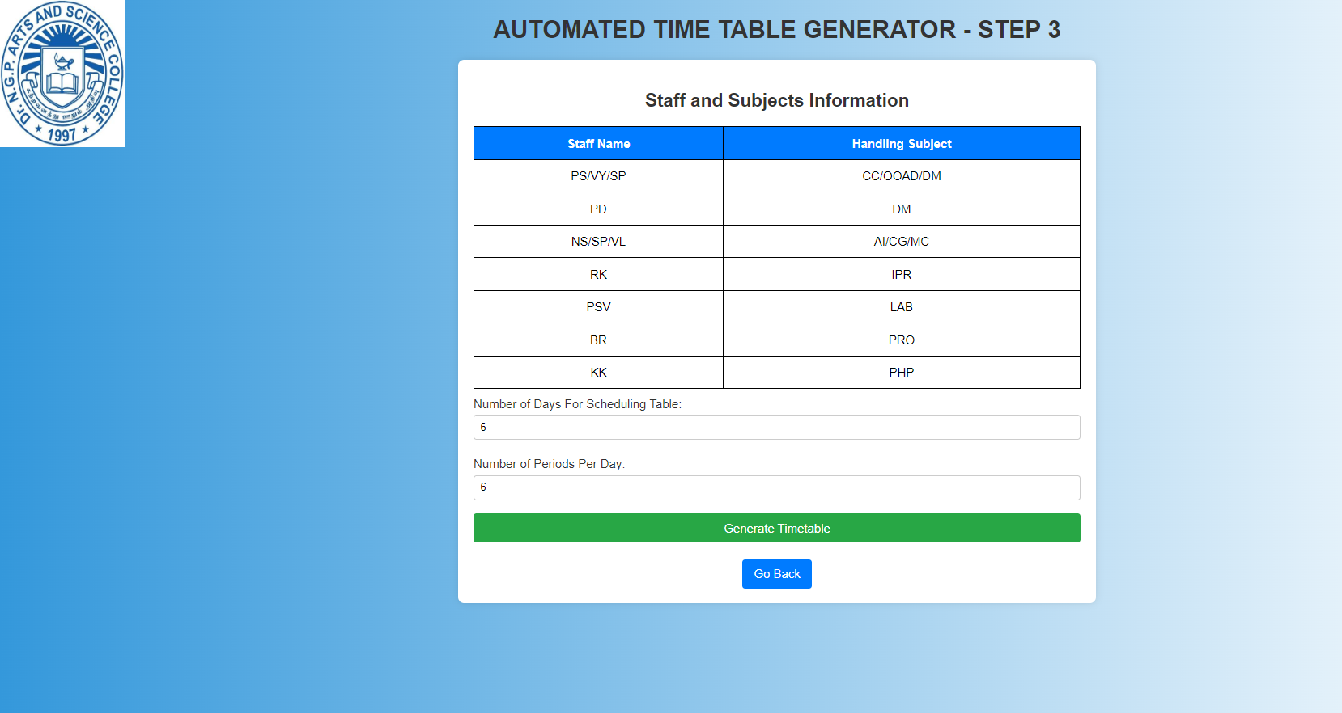

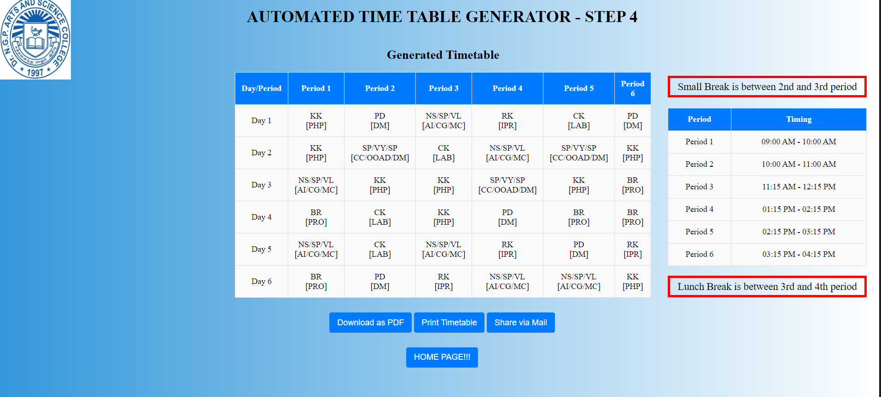

1. **SOURCE CODE**

**HOME PAGE**

<!DOCTYPE html>

<html xmlns="http://www.w3.org/1999/xhtml">

<head>

<meta charset="utf-8"/>

<meta name="viewport" content="width=device-width, initial-scale=1, maximum-scale=1"/>

<meta name="description" content=""/>

<meta name="author" content=""/>

<title>TimeTable Scheduling System</title>

<link href="assets/css/bootstrap.css" rel="stylesheet"/>

<link href="assets/css/font-awesome.min.css" rel="stylesheet"/>

<link href="assets/css/flexslider.css" rel="stylesheet"/>

<link href="assets/css/style.css" rel="stylesheet"/>

<link href='http://fonts.googleapis.com/css?family=Open+Sans:400,700,300' rel='stylesheet' type='text/css'/>

</head>

<body>

<div class="navbar navbar-inverse navbar-fixed-top " id="menu">

<div class="container">

<div align="center">

<h3 align="center">TIME TABLE SCHEDULING SYSTEM, Bachelor of Computer Applications</h3>

</div> </div> </div>

<div id="myCarousel" class="carousel slide" data-ride="carousel">

<ol class="carousel-indicators" style="margin-bottom: 160px">

<li data-target="#myCarousel" data-slide-to="0" class="active"></li>

</ol>

<div class="carousel-inner" role="listbox">

<div class="item active">

<img src="assets/img/contact.jpg" alt="dep">

</div> </div> </div>

<center>

<button data-scroll-reveal="enter from the bottom after 0.2s"

id="adminLoginBtn" class="btn btn-success btn-lg">FACULTY LOGIN

</button> </center>

</div>

<br>

<div id="myModal" class="modal">

<div class="modal-content">

<div class="modal-header">

<span class="close">&times</span>

<h2 id="popupHead">Modal Header</h2>

</div>

<div class="modal-body" id="LoginType">

<div style="display:none" id="adminForm">

<form method="POST" action="login.php" style="overflow: hidden">

<div class="form-group">

<label for="adminname">Username</label>

<input type="text" class="form-control" id="adminname" name="UN" placeholder="Username ...">

</div>

<div class="form-group">

<label for="password">Password</label>

<input type="password" class="form-control" id="password" name="PASS"

placeholder="Password ...">

</div>

<div align="right">

<input type="submit" class="btn btn-default" name="LOGIN" value="LOGIN">

</div> </form>

</div> </div>

</div></div>

<script>

var modal = document.getElementById('myModal');

var teacherLoginBtn = document.getElementById("teacherLoginBtn");

var adminLoginBtn = document.getElementById("adminLoginBtn");

var heading = document.getElementById("popupHead");

var facultyForm = document.getElementById("facultyForm");

var adminForm = document.getElementById("adminForm");

var span = document.getElementsByClassName("close")[0];

adminLoginBtn.onclick = function () {

modal.style.display = "block";

heading.innerHTML = "Admin Login";

adminForm.style.display = "block";

facultyForm.style.display = "none";

}

teacherLoginBtn.onclick = function () {

modal.style.display = "block";

heading.innerHTML = "Faculty Login";

facultyForm.style.display = "block";

adminForm.style.display = "none";

}

span.onclick = function () {

modal.style.display = "none";

adminForm.style.display = "none";

facultyForm.style.display = "none";

}

window.onclick = function (event) {

if (event.target == modal) {

modal.style.display = "none";

}

}

</script>

<div id="faculty-sec">

<div class="container set-pad">

<div class="row text-center">

<div class="col-lg-8 col-lg-offset-2 col-md-8 col-sm-8 col-md-offset-2 col-sm-offset-2">

<h1 data-scroll-reveal="enter from the bottom after 0.1s" class="header-line">OUR FACULTIES </h1>

</div> </div>

<div class="row">

<div class="col-lg-4 col-md-4 col-sm-4" data-scroll-reveal="enter from the bottom after 0.4s">

<div class="faculty-div">

<img src="assets/img/faculty/Dr.R.Kousalya.jpg" class="img-rounded"/>

<h3 align="center">Dr. R. Kousalya M.C.A., M. Phil., Ph.D.</h3>

<hr/>

<h4 align="center">Professor and Head<br/>F/o BCA</h4>

</div> </div>

<div class="col-lg-4 col-md-4 col-sm-4" data-scroll-reveal="enter from the bottom after 0.4s">

<div class="faculty-div">

<img src="assets/img/faculty/Dr.C.Kumuthini.jpg" class="img-rounded"/>

<h3 align="center">Dr.C.Kumuthini M.C.A., M. Phil., Ph.D.</h3>

<hr/>

<h4 align="center">Professor<br/>F/o BCA </h4>

</div> /div>

<div class="col-lg-4 col-md-4 col-sm-4" data-scroll-reveal="enter from the bottom after 0.4s">

<div class="faculty-div">

<img src="assets/img/faculty/Ms.K.Gomathy.jpg" class="img-rounded"/>

<h3 align="center">Ms.K.Gomathy M.C.A., M. Phil.</h3>

<hr/>

<h4 align="center">Assistant Professor(SG)<br/>F/o BCA </h4>

</div> </div>

<div class="col-lg-4 col-md-4 col-sm-4" data-scroll-reveal="enter from the bottom after 0.4s">

<div class="faculty-div">

<img src="assets/img/faculty/Mr.P.Dinesh Kumar.jpg" class="img-rounded"/>

<h3 align="center">Mr.P.Dinesh Kumar M.C.A., M. Phil., (Ph. D)</h3>

<hr/>

<h4 align="center">Assistant Professor(SG)<br/>F/o BCA </h4>

</div> </div>

<div class="col-lg-4 col-md-4 col-sm-4" data-scroll-reveal="enter from the bottom after 0.4s">

<div class="faculty-div">

<img src="assets/img/faculty/Dr.S. Poorana Senthilkumar.jpg" class="img-rounded"/>

<h3 align="center">Dr.S. Poorana Senthilkumar M.C.A., M. Phil., Ph.D.</h3>

<hr/>

<h4 align="center">Assistant Professor<br/>F/o BCA </h4>

</div> </div>

<div class="col-lg-4 col-md-4 col-sm-4" data-scroll-reveal="enter from the bottom after 0.4s">

<div class="faculty-div">

<img src="assets/img/faculty/Dr. P. S. Vijayalakshmi.jpg" class="img-rounded"/>

<h3 align="center">Dr. P. S. Vijayalakshmi M.C.A., M.Phil., SET., Ph.D.</h3>

<hr/>

<h4 align="center">Assistant Professor<br/>F/o BCA </h4>

</div> </div>

<div class="col-lg-4 col-md-4 col-sm-4" data-scroll-reveal="enter from the bottom after 0.4s">

<div class="faculty-div">

<img src="assets/img/faculty/Dr.B.Ramya.jpg" class="img-rounded"/>

<h3 align="center">Dr.B.Ramya M.C.A., M.Phil., Ph.D.</h3>

<hr/>

<h4 align="center">Assistant Professor<br/>F/o BCA </h4>

</div> </div>

<div class="col-lg-4 col-md-4 col-sm-4" data-scroll-reveal="enter from the bottom after 0.5s">

<div class="faculty-div">

<img src="assets/img/faculty/Dr.K.Kavitha.jpg" class="img-rounded"/>

<h3 align="center">Dr.K.Kavitha M.C.A., M. Phil., Ph. D.</h3>

<hr/>

<h4 align="center">Assistant Professor<br/>F/o BCA</h4>

</div>

</div>

<div class="col-lg-4 col-md-4 col-sm-4" data-scroll-reveal="enter from the bottom after 0.5s">

<div class="faculty-div">

<img src="assets/img/faculty/Mr.V.Yuvaraj.jpg" class="img-rounded"/>

<h3 align="center">Mr.V.Yuvaraj M.C.A., M. Phil., (Ph.D.)</h3>

<hr/>

<h4 align="center">Assistant Professor<br/>F/o BCA</h4>

</div> </div> </div> </div> </div>

<div class="container">

<div class="row set-row-pad">

<div class="col-lg-4 col-md-4 col-sm-4 col-lg-offset-1 col-md-offset-1 col-sm-offset-1 "

data-scroll-reveal="enter from the bottom after 0.4s">

<h2><strong>Our Location </strong></h2>

<hr/> <div>

<h4>C1 BLock 4th Floor,

</h4>

<h4>BCA</h4>

<h4><strong>Call:</strong>1234567890</h4>

<h4><strong>Email: </strong>bca@gmail.com</h4>

</div> </div>

<div class="col-lg-4 col-md-4 col-sm-4 col-lg-offset-1 col-md-offset-1 col-sm-offset-1"

data-scroll-reveal="enter from the bottom after 0.4s">

<h2><strong>Social Conectivity </strong></h2>

<hr/>

<div>

<a href="#"> <img src="assets/img/Social/facebook.png" alt=""/> </a>

<a href="https://www.drngpasc.ac.in/best-bca-college-in-coimbatore-tamilnadu"> <img src="assets/img/Social/google-plus.png" alt=""/></a>

<a href="#"> <img src="assets/img/Social/twitter.png" alt=""/></a>

</div> </div> </div> </div>

<script src="assets/js/jquery-1.10.2.js"></script>

<script src="assets/js/bootstrap.js"></script>

<script src="assets/js/jquery.flexslider.js"></script>

<script src="assets/js/scrollReveal.js"></script>

<script src="assets/js/jquery.easing.min.js"></script>

<script src="assets/js/custom.js"></script>

</div>

</body>

</html>

**TIMETABLE GENERATION PAGE**

<?php

session_start();

?>

<!DOCTYPE html>

<html lang="en">

<head>

<img class="top-left-image" src="./assets/img/ngp.jpg" alt="Your Image"></a>

<meta charset="UTF-8">

<meta name="viewport" content="width=device-width, initial-scale=1.0">

<title>Step-4</title>

<script src="https://cdnjs.cloudflare.com/ajax/libs/html2pdf.js/0.9.2/html2pdf.bundle.js"></script>

<style>

body {

background: linear-gradient(to right, #3498db, #ffffff);

}

body {

text-align: center;

}

.container {

max-width: 800px;

margin: 0 auto;

display: flex;

justify-content: space-between;

}

.column {

flex: 0 0 48%; /* Adjust width as needed */

}

table {

border-collapse: collapse;

width: 100%;

margin-top: 20px;

background-color: #f9f9f9;

}

th, td {

border: 1px solid #ddd;

padding: 12px;

text-align: center;

}

th {

background-color: #007BFF;

color: #fff;

}

@media (max-width: 600px) {

table {

font-size: 12px;

}

}

@media print {

body * {

visibility: hidden;

}

.container, .container * {

visibility: visible;

}

.container {

position: absolute;

left: 0;

top: 0;

}

}

/* Styling for the "Go Back" button */

button {

background-color: #007BFF;

color: #fff;

padding: 10px 15px;

font-size: 16px;

cursor: pointer;

border: none;

border-radius: 4px;

margin-top: 10px;

}

button:hover {

background-color: #0056b3;

}

body {

margin: 0; /* Remove default margin */

padding: 0; /* Remove default padding */

}

.top-left-image {

position: absolute; /* Set the position property to absolute */

top: 0; /* Set the distance from the top edge to 0 */

left: 0; /* Set the distance from the left edge to 0 */

height:20%;

width:8%;

}

</style>

</head>

<body>

<h1>AUTOMATED TIME TABLE GENERATOR - STEP 4</h1>

<div class="container">

<div class="column">

<h2>Generated Timetable</h2>

<?php

if ($_SERVER["REQUEST_METHOD"] == "POST" && isset($_POST['num_days']) && isset($_POST['num_periods'])) {

$numDays = $_POST['num_days'];

$numPeriods = $_POST['num_periods'];

$staffNames = json_decode(htmlspecialchars_decode($_POST['staff_names']), true);

if (!isset($_SESSION['timetable'])) {

$timetable = [];

for ($day = 1; $day <= $numDays; $day++) {

for ($period = 1; $period <= $numPeriods; $period++) {

$randomKey = array_rand($staffNames);

$staffName = $staffNames[$randomKey];

$subject = $randomKey;

$timetable[$day][$period]['staff'] = $staffName;

$timetable[$day][$period]['subject'] = $subject;

}

}

$_SESSION['timetable'] = $timetable;

} else {

$timetable = $_SESSION['timetable'];

}

}

if (isset($timetable)) {

echo '<table>';

echo '<tr><th>Day/Period</th>';

for ($period = 1; $period <= $numPeriods; $period++) {

echo '<th>Period ' . $period . '</th>';

}

echo '</tr>';

for ($day = 1; $day <= $numDays; $day++) {

echo '<tr>';

echo '<td>Day ' . $day . '</td>';

for ($period = 1; $period <= $numPeriods; $period++) {

$staffName = $timetable[$day][$period]['staff'];

$subject = $timetable[$day][$period]['subject'];

echo '<td>' . $staffName . '<br>[' . $subject . ']</td>';

}

echo '</tr>';

}

echo '</table>';

}

?>

</div>

&nbsp;&nbsp;&nbsp;&nbsp;&nbsp;&nbsp;&nbsp;&nbsp;

<div class="column">

<!-- Second table for period timings -->

<table>

<?php

echo '<br><br><br><br><div style="border:5px solid red; padding:5px; font-size: 20px; font-family: "Arial", sans-serif; color: #0066cc;">';

echo 'Small Break is between 2nd and 3rd period</div>';

?>

<tr><th>Period</th><th>Timing</th></tr>

<?php

$period_timings = array(

"1" => "09:00 AM - 10:00 AM",

"2" => "10:00 AM - 11:00 AM",

"3" => "11:15 AM - 12:15 PM",

"4" => "01:15 PM - 02:15 PM",

"5" => "02:15 PM - 03:15 PM",

"6" => "03:15 PM - 04:15 PM",

"7" => "04:15 PM - 05:00 PM",

"8" => "05:00 PM - 05:30 PM",

);

for ($period = 1; $period <= $numPeriods; $period++) {

echo '<tr>';

echo '<td>Period ' . $period . '</td>';

echo '<td>' . $period_timings[$period] . '</td>';

echo '</tr>';

}

?>

</table>

<?php

echo '<br><div style="border:5px solid red; padding:5px; font-size: 20px; font-family: "Arial", sans-serif; color: #0066cc;">';

echo 'Lunch Break is between 3rd and 4th period</div>';

?>

</div>

</div>

<div>

<br>

<button onclick="downloadPDF()">Download as PDF</button>

<button onclick="printTimetable()">Print Timetable</button>

<button style="background-color: #007BFF; color: #fff; padding: 10px 15px; font-size: 16px; cursor: pointer; border: none; border-radius: 4px; margin-top: 10px;">

<a href="mailto:211ca006@drngpasc.ac.in" style="text-decoration: none; color: inherit;">Share via Mail</a></button>

<br><br>

<button onclick="goback()">HOME PAGE!!!</button>

<script>

function downloadPDF() {

// Convert the timetable content to a printable format

var content = generatePDFContent();

// Create a PDF using html2pdf.js

html2pdf(content, {

margin: 10,

filename: 'timetable.pdf',

image: { type: 'jpeg', quality: 0.98 },

html2canvas: { scale: 2 },

jsPDF: { unit: 'mm', format: 'a4', orientation: 'portrait' }

});

}

function generatePDFContent() {

// Generate content for the PDF based on your timetable data

var content = '<h1 style="text-align: center; font-size: 16px;">Generated Timetable</h1>';

<?php

if (isset($timetable)) {

echo 'content += "<table style=\'width: 100%; border-collapse: collapse; font-size: 12px;\' border=\'1\' cellspacing=\'0\' cellpadding=\'3\'>";';

echo 'content += "<tr style=\'background-color: #007BFF; color: #fff; text-align: center;\'>";';

echo 'content += "<th>Day/Period</th>";';

for ($period = 1; $period <= $numPeriods; $period++) {

echo 'content += "<th>Period ' . $period . '</th>";';

}

echo 'content += "</tr>";';

for ($day = 1; $day <= $numDays; $day++) {

echo 'content += "<tr>";';

echo 'content += "<td style=\'text-align: center;\'>Day ' . $day . '</td>";';

for ($period = 1; $period <= $numPeriods; $period++) {

$staffName = $timetable[$day][$period]['staff'];

$subject = $timetable[$day][$period]['subject'];

echo 'content += "<td style=\'text-align: center; padding: 2px;\'>' . $staffName . '<br>[' . $subject . ']</td>";';

}

echo 'content += "</tr>";';

}

echo 'content += "</table>";';

}

?>

return content;

}

function printTimetable() {

window.print();

}

function goback() {

location.replace("t.php")

}

</script>

</div>

</body>

</html>